**Gilbert Temple Info**

Address

3301 S Greenfield Rd

Gilbert AZ 85297

United States

Telephone

(1) 480-822-5000

Services

Clothing rental available

No cafeteria available

No patron housing available

Distribution center nearby

2019 Closures

Thursday, 4 July 2019

Monday, 30 September 2019 - Monday, 14 October 2019

Wednesday, 27 November 2019 - Thursday, 28 November 2019

Tuesday, 24 December 2019 - Wednesday, 25 December 2019

Tuesday, 31 December 2019

Milestones

10 April 2008 Announced

13 November 2010 Groundbreaking

2 March 2014 Dedicated — dedicatory prayer

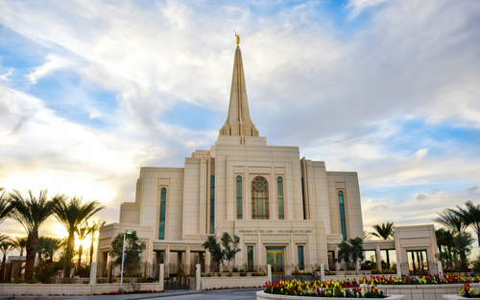

Reference: <https://www.lds.org/temples/details/gilbert-arizona-temple?lang=eng>